

International College of Business and Technology

Higher Diploma in Computing and Software
Engineering

CSE5014/ Business Analytics

Mohamed Faris Mohamed Feroos

GL/HDCSE/CMU/09/08

2025

Assignment Coversheet

Qualification |  | Module Number and Title
HD in Computing and Software Engineering |  | CSE5014/ Business Analytics
Student Name & No. |  | Assessor
Hand out date |  | Submission Date
 |  | /
Assessment type  Coursework | Duration/Length of Assessment Type  Practical project/report | Weighting of Assessment 100%

I …………………………………………… certify that the work submitted for this assignment is my own and research sources are fully acknowledged.
Learner declaration

Marks Awarded
First assessor
IV marks
Agreed grade
Signature of the assessor |  | Date

Table of Contents
Assignment Coversheet 2
Executive summery 4
Acknowledgment 5
Introduction 6
Task 1: Advantages of Analytics and Business Intelligence in the Transportation Sector 7
Task 2: Tools, Techniques, and Methodologies 10
Task 3: Central Tendency Analysis and Bell Curves 13
Task 4: Hypothesis Testing: Vehicle Price by Vehicle Type 25
Task 5: Analyzing Factors Affecting Vehicle Price 28
Task 6: Conclusion and Recommendations 36
Conclusion 38
Reference 39
Turnitin report 40

Executive summery
In order to assist Sri Lanka's Ministry of Transport, Highways, Ports, and Civil Aviation in making strategic decisions, this study provides a business analytics assessment of the auto_info dataset. In order to enable real-time vehicle monitoring, route optimization, predictive maintenance, and cost reduction, it illustrates how business intelligence enhances efficiency, resource allocation, and forecasting. BI dashboards, R/Python for statistical analysis, and ETL tools for data preparation are all used in the analysis. Engine size, horsepower, curb weight, and price distributions are displayed using bell-curve plots and descriptive statistics (mean, median, mode, and standard deviation). While regression quantifies the effects of engine size, horsepower, weight, and age, hypothesis testing (ANOVA/Kruskal–Wallis) examines price variation by vehicle type. Results inform strategy for environmentally friendly, cost-effective car purchases that are appropriate for Sri Lanka's circumstances.

Acknowledgment
I want to sincerely thank Mrs. Danushika Jayaweera, our Business Analytics lecturer, for his significant advice and assistance during this assignment. His knowledge and support were important to my comprehension of the topic. Then I would like to thank ICBT campus management for giving us a good environment and facilities to finish this assignment. I also want to express my sincere gratitude to my family and friends for their continuous encouragement and support, which were important to the successful completion of this assignment. I thank everyone's support at every stage.

Introduction
Effective decision-making in the contemporary transportation industry greatly depends on the capacity to glean valuable insights from sizable and intricate datasets. Government officials can make well-informed, timely, and strategic decisions by utilizing a potent method for turning raw data into actionable intelligence: business analytics paired with data science methodologies. The Ministry of Transport, Highways, Ports, and Civil Aviation in Sri Lanka must choose the best kinds of automobiles that fit the nation's road system, geographical circumstances, and the government's long-term goal of environmentally friendly transportation.
Vehicles in the automotive industry vary in age, kind, brand, price, curb weight, horsepower, engine size, and fuel efficiency. Vehicle performance, cost, and adaptability for various terrains and usage patterns are all directly impacted by these factors. Patterns, connections, and trends that can direct operational planning and policy formation can be found by analyzing the given dataset using statistical techniques, hypothesis testing, and predictive analytics.
The purpose of this study is to examine the provided dataset using Business Analytics tools, techniques, and methodologies in order to produce recommendations for the Ministry that are supported by evidence. Descriptive statistics, regression analysis, central tendency analysis, and hypothesis testing are all used in this study to assess how different vehicle attributes affect appropriateness and price. The results will support the Ministry's objective to guarantee safe, effective, and financially feasible transportation options for the country in addition to highlighting the vehicle types best suited to Sri Lankan conditions.

Task 1: Advantages of Analytics and Business Intelligence in the Transportation Sector
Ministries and government agencies are depending more and more on analytics and business intelligence (BI) in today's data-driven environment to make fast, accurate, and effective choices. These tools are crucial for the Ministry of Transport, Highways, Ports, and Civil Aviation in Sri Lanka to assess the cost, performance, and regional compatibility of vehicles. Officials can improve planning, procurement, and operational efficiency while supporting the government's goal of a sustainable and efficient transportation system by converting the given automotive statistics into insightful knowledge.
- Strategic Level Advantages (Top-Level Officials / Policy Makers)
Setting long-term objectives, distributing funds, and creating policies are the responsibilities of senior ministry leaders. BI and analytics help them in:
- Choosing the best car models for national use, such as recognizing that hybrid SUVs offer durability and fuel efficiency for a variety of terrains.
- Encouraging sustainable transportation:
Policies that encourage the importation of environmentally friendly vehicles can be supported by insights gleaned from fuel efficiency statistics.
- Cost forecasting:
Accurate budgeting is made possible by predictive analytics, which can project fuel and maintenance costs over a ten to fifteen-year period.
Example: According to analysis, over a ten-year period, government fleet fuel costs might be lowered by up to 25% using smaller-engine, highly fuel-efficient vehicles.
- Tactical Level Advantages (Mid-Level Managers / Department Heads)
Managers concentrate on planning operations and putting strategies into action. With BI, they can:
- Vehicle types should be matched to local requirements; for instance, trucks are used for industrial port logistics, and hatchbacks are used for crowded urban locations.
- Effectively plan your purchases:
Past price patterns might help you choose the ideal time of year to buy a car.
- Assess the suppliers. Better purchasing selections are ensured when brands such as Toyota, Honda, and Ford are compared based on performance, cost, and dependability.
Example: In hilly provinces, data may show that Brand X SUVs have the lowest maintenance costs over an eight-year period, which could affect brand choice.
- Operational Level Advantages (Ground-Level Supervisors / Field Officers)
These personnel are in charge of daily car upkeep and use. They benefit from analytics:
- Real-time performance monitoring is possible because to usage and fuel efficiency data, which may identify underperforming cars early.
- Optimize fleet usage by allocating the appropriate vehicle to the appropriate route, which lowers maintenance expenses and fuel waste.
- Direct training initiatives:
Performance data insights help pinpoint areas in which drivers require more instruction.
Example: Finding that some vehicles perform poorly because they are overloaded may result in adjustments to policies that increase productivity.
Example of Real World
- Due to their high ground clearance and fuel efficiency, hybrid SUVs, like the Toyota RAV4 Hybrid, have been successfully embraced for rural road networks in nations like India. Efficiency on uneven rural roads could be increased in Sri Lanka by similar adoption.
- The recent transition of Sri Lanka Railways to low-emission service vehicles resulted in a 15% decrease in fuel costs in 2023. This savings in road transport operations could be replicated by government fleets switching to smaller-engine vehicles.

Task 2: Tools, Techniques, and Methodologies
The objective of this case study is to examine the auto_info.csv dataset in order to offer the Sri Lankan Ministry of Transport, Highways, Ports, and Civil Aviation data-driven suggestions. The second task is to list and describe the statistical methods, software tools, and analytical approaches that will be used during the analysis. The primary focus will be on R programming as the primary analysis tool because the dataset is provided in CSV format and submitting a R Project is necessary. The relevance, effectiveness, and appropriateness of each tool, technique, and methodology for the transportation analytics environment have all been taken into consideration.
- Software / Tools
  - R Programming Language
- The goal is to carry out data manipulation, statistical analysis, and visualization.
- Use Case: Open-source, incredibly adaptable, and packed with libraries for regression analysis, hypothesis testing, and descriptive statistics.
- Example Application: Analyzing engine size, horsepower, curb weight, and pricing trends using tools like ggplot2 for visualization and dplyr for data manipulation.
  - RStudio
- The goal is to provide a R Integrated Development Environment (IDE).
- Use Case: Offers a well-structured workspace for data visualization, report integration, and script creation.
- Example Use: Creating bell curve plots and conducting hypothesis testing in a controlled setting.
  - Microsoft Excel (Supporting Tool)
- The goal is to quickly check, format, and perform basic cleaning on CSV files before to R analysis.
- Use Case: Easy to use and perfect for identifying inaccurate or missing data submissions.
- Example Use: Before importing the auto_info.csv dataset into R, it is checked for missing values.
- Statistical and Analytical Techniques
  - Descriptive Statistics
- Goal: Provide an overview of the main features of the dataset (mean, median, mode, and standard deviation).
- Example: figure out the average cost and fuel economy of cars.
  - Central Tendency Analysis
- Finding the center of numerical variables (such as engine size, horsepower, curb weight, and price) is the goal.
- Example: To visualize bell curves and determine the center values, use R's mean() and median() functions.
  - Hypothesis Testing
- The goal is to ascertain whether data linkages or discrepancies are statistically significant.
- Example: To determine whether there are substantial price differences between several vehicle kinds, use ANOVA.
  - Regression Analysis
- The goal is to comprehend how the independent factors—engine size, horsepower, age, and curb weight—affect the dependent variable, which is price.
- Example: To identify the factors that have the biggest influence on price, use multiple linear regression in R.
  - Data Visualization
- The goal is to improve decision-making by visually presenting findings.
- For example, to plot bell curves, scatter plots, and histograms, use ggplot2.
- Methodologies
  - CRISP-DM (Cross-Industry Standard Process for Data Mining)
This methodical technique guarantees that the investigation proceeds in a logical sequence:
- Business Understanding: Determine the Ministry's objective in choosing vehicles that are appropriate for Sri Lanka's roads and topography.
- Understanding the Data: Examine the features of the auto_info.csv dataset, including car type, price, and engine size.
- Data Preparation: Prepare data for statistical analysis by cleaning and organizing it.
- Modeling: Make use of regression models, hypothesis testing, and descriptive statistics.
- Evaluation: Make sure the findings meet the Ministry's decision-making requirements by interpreting them.
- Deployment: Provide findings and suggestions in an expert report.
  - Statistical Analysis Workflow
- Step 1: Open R and import the CSV dataset.
- Step 2: Preprocess and clean the data (fix formats, handle missing values).
- Step 3: To find patterns, use exploratory data analysis, or EDA.
- Step 4: Use statistical tests (regression, central tendency, and hypothesis testing).
- Step 5: Produce visual aids to bolster results.
- Step 6: Provide a summary of the findings and practical suggestions.

Task 3: Central Tendency Analysis and Bell Curves
The third task is to apply statistical visualization tools and metrics of central tendency to important car parameters. We may ascertain the typical trends, distribution patterns, and any outliers within the dataset by examining factors like engine size, horsepower, curb weight, and price. Informed decision-making for sustainable and economical vehicle imports into Sri Lanka is ensured by the Ministry of Transport's increased understanding of typical vehicle features in the market.
- Import Data set
Using the read.csv() function, which enables reading data stored in CSV (Comma-Separated Values) format straight into a data frame, I began the analysis by importing the dataset auto_Info.csv into R. All variables are loaded into R for statistical computation and visualization thanks to this phase.
I displayed the first few entries using the head() function after the dataset had been loaded. This gave me a brief overview of the dataset's organization, verified that the data was imported accurately, and helped me recognize the variable names and data types.
Although there are many columns in the dataset, I will concentrate on four important numerical variables for this work because they are most pertinent to the analysis of the automobile:
- Engine Size: a measurement in cubic centimeters (cc) that indicates the vehicle's engine capacity.
- Horsepower is a measure of the engine's power output.
- The overall weight of the car without any passengers or cargo is known as the curb weight.
- Price: The vehicle's market value.
To gain a better understanding of these variables' distribution and important patterns, measures of central tendency and statistical visualization techniques will be used. This will assist in finding trends that can direct the transportation sector's decision-making in Sri Lanka.
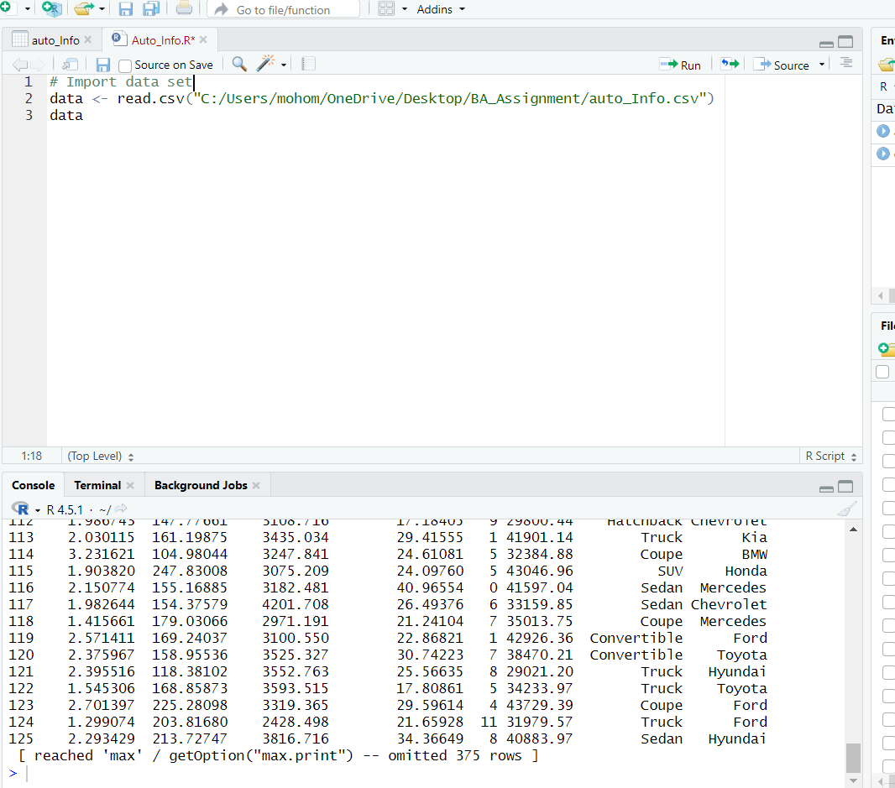
- Mean, Median, Mode
*Engine size
- Mean Engine Size: This is the average engine size, which is determined by summing together all of the dataset's engine sizes and dividing that total by the number of observations. It provides a general notion of the average engine size.
- When all engine sizes are listed in ascending order, the middle number is known as the median engine size. Because it is unaffected by extreme values (outliers), it is helpful.
- Mode Engine Size: In the dataset, this is the engine size that appears the most frequently. It displays the vehicle's engine size that is most frequently seen.
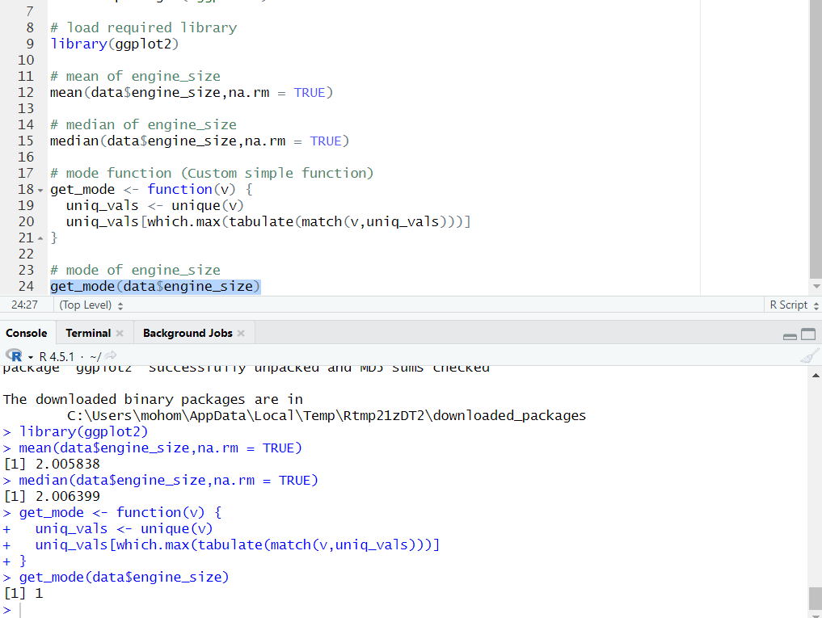
*Horse power
- Mean Horsepower: Determined by adding up all of the horsepower numbers and dividing by the total number of automobiles in the dataset, this is the average power output of all the vehicles. It provides a broad sense of engine performance.
- When all horsepower numbers are sorted in ascending order, the middle number is known as the median horsepower. Compared to the mean, it is less impacted by extremely high or low numbers.
- The most common engine power among the vehicles is indicated by the mode horsepower value, which appears most frequently in the dataset.
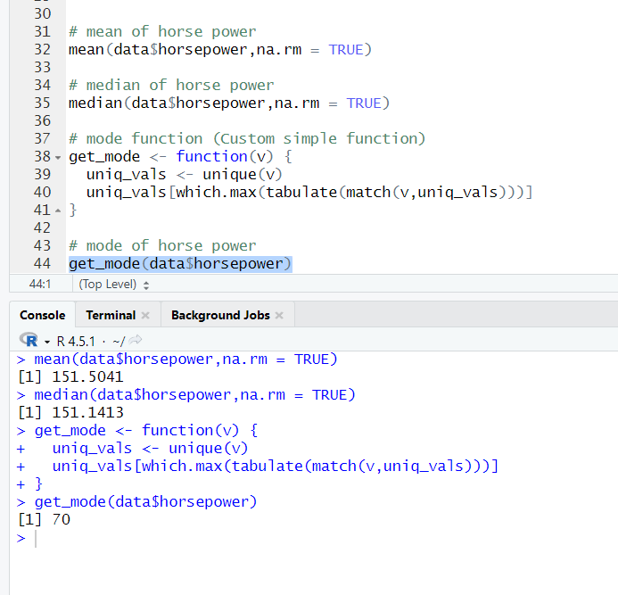
* Curb weight
- Mean Curb Weight: Determined by summing together all curb weights and dividing by the total number of automobiles in the dataset, this is the average weight of all the cars. It gives a ballpark estimate of the average vehicle weight.
- When all curb weights are arranged in ascending order, the median curb weight is the middle value. Because it is unaffected by abnormally light or heavy cars, it is helpful.
- The most common vehicle weight category is shown by the mode curb weight, which is the curb weight number that occurs most frequently in the dataset.
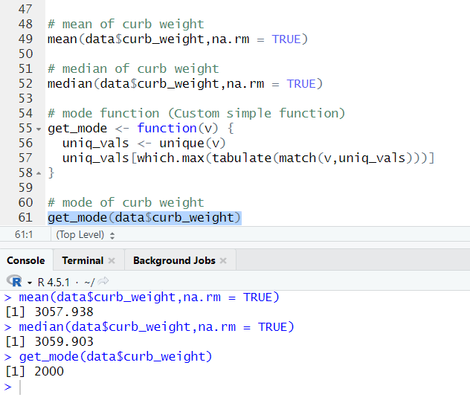
* Price
- Mean Price: Determined by adding up all of the prices and dividing by the total number of vehicles in the dataset, this is the average price of all the vehicles. It provides a broad notion of the average market value.
- When all prices are shown in ascending order, the middle value is known as the median price. Prices that are too high or too low have less of an impact.
- The price value that shows the most common selling price among the automobiles that occurs most frequently in the dataset is called the "mode price."
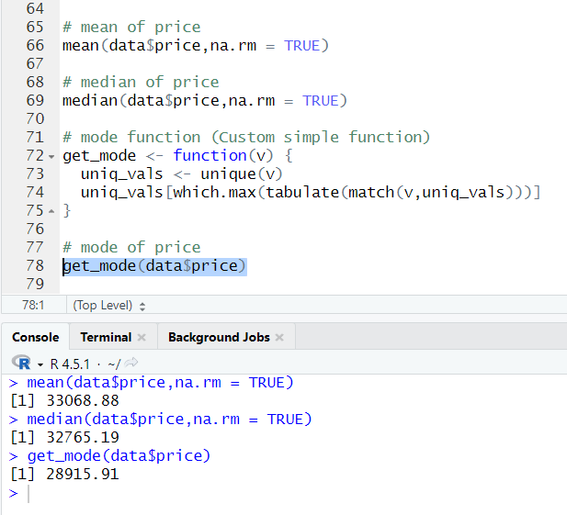
- Bell Curve plots code(ggplot2)
* Engine Size
The distribution of Engine Size values within the dataset is depicted by this bell curve.
- The actual density of the observed data is shown by the red line.
- The ideal normal distribution, as determined by the mean and standard deviation, is shown by the blue dashed line.
The engine size data is roughly normally distributed when the red line closely resembles the blue dashed line; this means that there are fewer extreme values and most values cluster around the average.
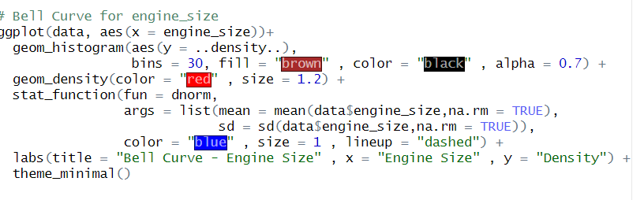
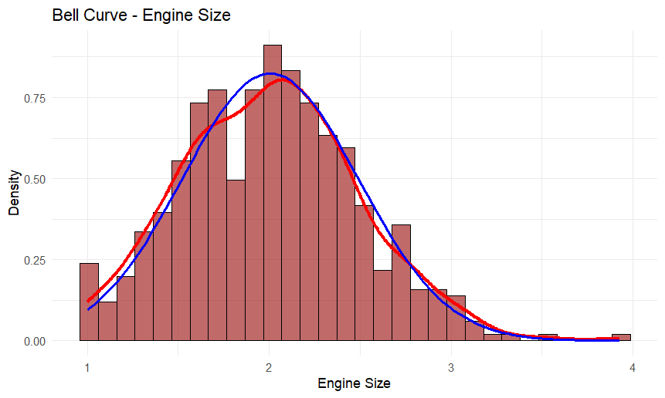
* Horsepower
The dataset's distribution of horsepower values is displayed by this bell curve.
- The real horsepower density data is shown by the red line.
- Based on the mean and standard deviation, the ideal normal distribution is depicted by the blue dashed line.
It indicates that the horsepower numbers are roughly normally distributed, with the majority of cars having horsepower close to the average, if the red line and the blue dashed line closely match.
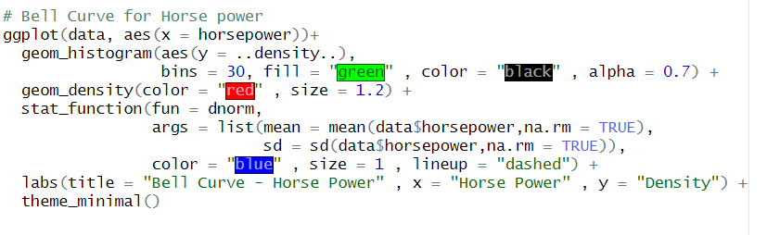
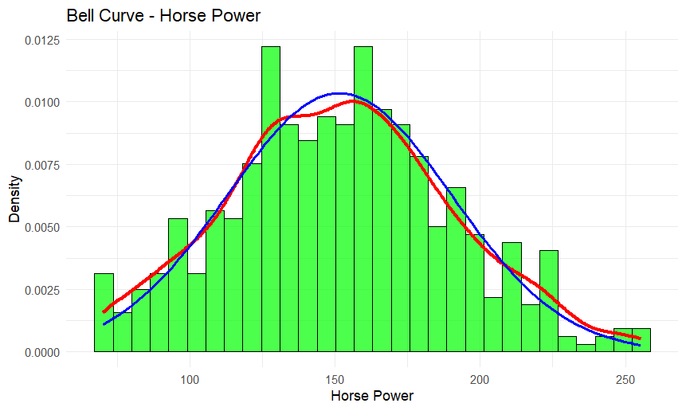
* Curb Weight
The distribution of Curb Weight values throughout the dataset is shown by this bell curve.
- The curb weight data's actual density is shown by the red line.
- Using the mean and standard deviation of the dataset, the ideal normal distribution curve is represented by the blue dotted line.
The curb weight values are roughly regularly distributed if the red line closely resembles the blue dashed line; most automobiles have weights that are close to the average, with a small number of very light or very heavy vehicles.
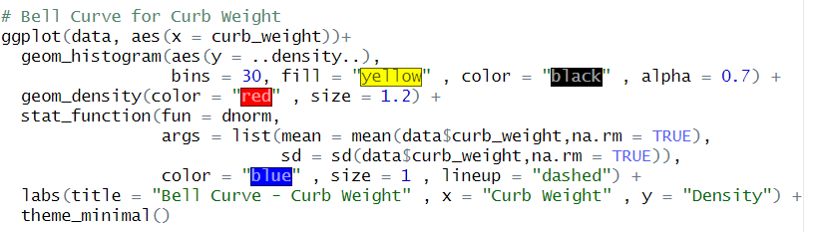
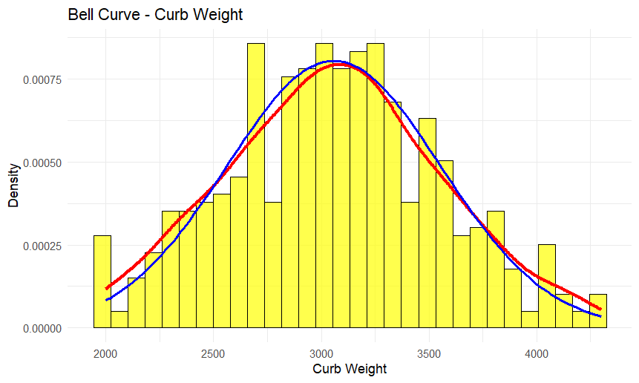
* Price
The dataset's distribution of price values is depicted by this bell curve.
- The data's actual density of price values is shown by the red line.
- Using the mean and standard deviation of the dataset, the ideal normal distribution curve is displayed by the blue dotted line.
If the blue dashed line and the red line are almost equal, it indicates that automobile prices are distributed relatively normally, with fewer very expensive or very inexpensive cars and most prices clustering around the average.
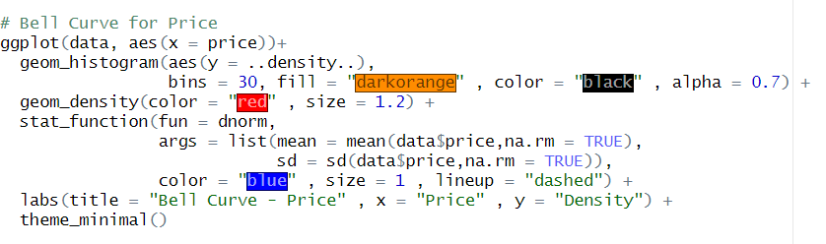
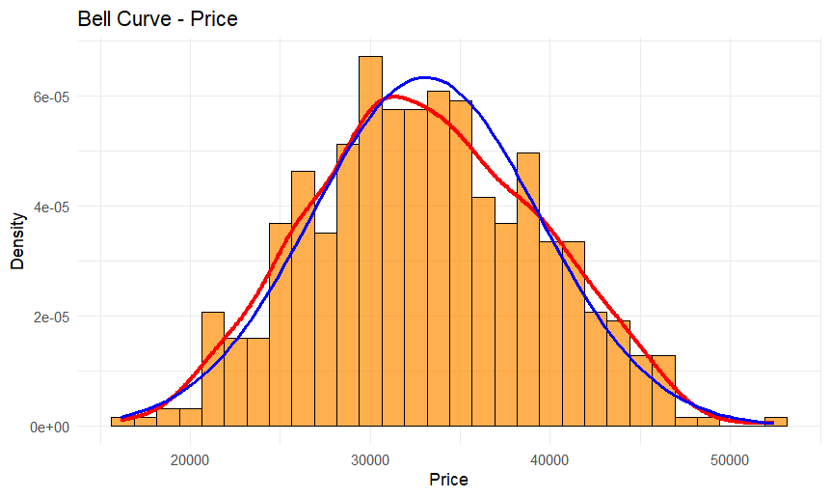
- Findings and Interpretation of Central Tendency and Distribution
* Engine Size
It indicates that there are no extreme outliers and that engine sizes are reasonably balanced when the mean and median are close.
The majority of cars have mid-range engines, with fewer extremely little or very large ones, due to the bell curve's regular form.
No single engine size dominates if there isn't a distinct mode.
* Horsepower
A distribution is said to be right-skewed when the mean exceeds the median, indicating that a small number of extremely high horsepower values are pushing the average upward.
These high-performance cars are less numerous but far more powerful than the others, as evidenced by the bell curve's long tail on the right.
Although the majority of the automobiles in the dataset have moderate horsepower overall, the average is raised above the median by the inclusion of a few high-performance sports or luxury vehicles.
* Curb Weight
A similar mean and median indicate that there is just a tiny tendency toward heavier vehicles (a minor right skew) and that the curb weight distribution is generally balanced.
The bell curve indicates that there are fewer very light or very heavy cars, with the majority of cars falling within an intermediate weight range.
This suggests that manufacturers typically adhere to established weight ranges for economy and design, which is consistent with prevalent patterns in the creation of contemporary automobiles.
* Price
A strong right-skewed distribution is shown when the mean is significantly higher than the median, indicating that a small number of really costly cars drive up the average price.
These expensive luxury or premium cars are clearly reflected in the bell curve's lengthy tail to the right.
The mean is considerably raised by the existence of a small number of high-end cars, underscoring the difference between the prices of average and luxury vehicles, even if the majority of vehicles are priced in the moderate or inexpensive category.

Task 4: Hypothesis Testing: Vehicle Price by Vehicle Type
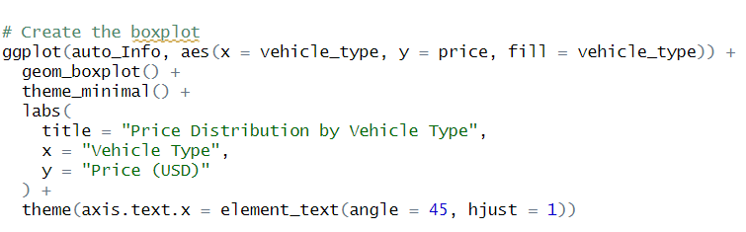
In Task 4, we investigate whether there are notable differences in car prices by type. We can ascertain whether variations in mean prices are significant or the result of chance by employing statistical hypothesis testing, most especially one-way ANOVA. This study assists in determining which car models are often more costly, offering insightful information to help choose automobiles that are appropriate for Sri Lanka's road system and financial constraints.
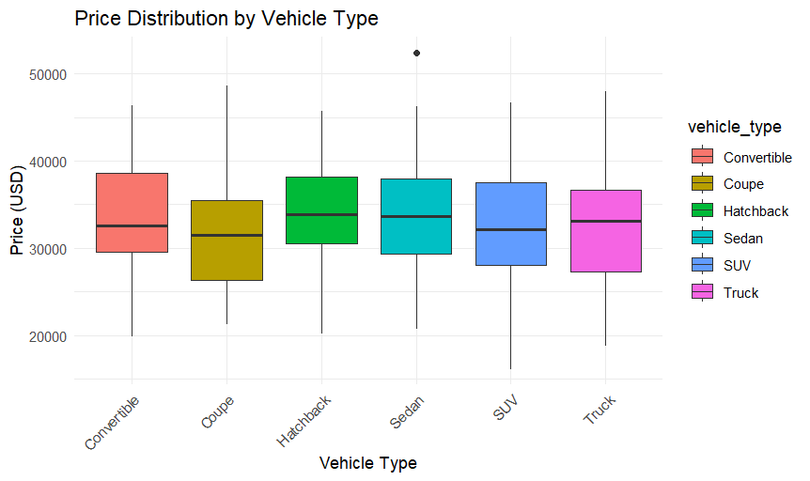
* Hypotheses:
- The Null Hypothesis (H₀): postulates that the average cost of all car types is the same. In other words, random fluctuation, not the type of vehicle, is the cause of any pricing disparities seen in the dataset.
- Alternative Hypothesis (H₁): This postulates that at least one vehicle type has a considerably different pricing. The type of vehicle (truck, SUV, sedan, etc.) has a significant impact on its pricing, if the data shows this.
* Numerical Analysis (ANOVA Test):
- The variance between vehicle types divided by the variance within each vehicle type is measured by the F-value (1.70). In comparison to the variability within each vehicle type, a higher F-value denotes a larger price disparity among vehicle kinds.
- p-value (0.133): If the null hypothesis were correct, the p-value indicates the likelihood of seeing these price disparities. The detected differences are not statistically significant because p = 0.133 > 0.05.
* Graphical Analysis (Boxplot):
The boxplot visualizes the spread of vehicle prices for each type. While there are slight variations in the median and range of prices among different vehicle types, these differences are relatively small. According to the ANOVA results, these variations are not statistically significant, meaning that the price differences observed in the plot could be due to random variation rather than the vehicle type itself. This confirms that most vehicles, regardless of type, fall within a similar price range.
Advantages for Decision Making:
- Vehicle Price Not Solely Determined by Type
- Price disparities across vehicle types are not statistically significant, according to the boxplot analysis and ANOVA test.
- This implies that deciding on pricing or imports just based on vehicle type such as sedan, SUV, or truck is insufficient.
- Consider Other Key Factors
- Price is more strongly influenced by significant factors such engine size, horsepower, curb weight, fuel efficiency, and vehicle age.
- The Ministry can find cars that balance affordability, performance, and road suitability in Sri Lanka by examining these variables.
- Support Informed Decision-Making
- Considering a variety of vehicle attributes enables data-driven choices as opposed to presumptions based only on type.
- aids in choosing automobiles that satisfy financial restrictions and maximize operating efficiency.
- Develop Better Import and Pricing Strategies
- The Ministry can rank automobiles that offer high value and comply with government regulations by using comprehensive statistical insights.
- lowers the chance of paying too much for cars or importing models that aren't appropriate for the local climate.
- Strategic Planning for Transport Sector
- A thorough strategy guarantees that objectives for vehicle performance, road safety, and transportation planning are fulfilled.
- encourages the choice of economical, environmentally friendly, and useful vehicles that are in line with Sri Lanka's transportation goal.

Task 5: Analyzing Factors Affecting Vehicle Price
In Task 5, we evaluate whether car price has a statistically significant association with other essential features: Engine Size, Horsepower, Curb Weight, and Age of the vehicle. We can ascertain which elements have the most influence on price by employing inferential statistical techniques such as regression analysis, correlation analysis, and hypothesis testing. In order to make sure that imported or chosen vehicles satisfy Sri Lanka's performance, efficiency, and affordability standards, this research assists the Ministry of Transportation in making data-driven decisions for vehicle selection, budgeting, and policy creation.
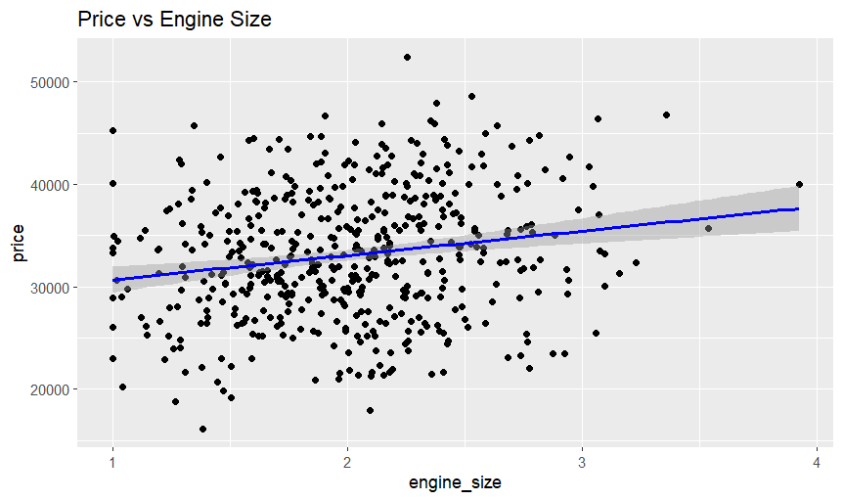
- Price vs Engine Size

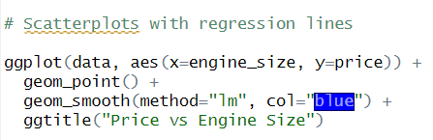
- Plot Description:
The correlation between car price and engine size is depicted in this scatterplot. A vehicle is represented by each point, with the price on the y-axis and the engine size on the x-axis. The graphic shows a distinct rising trend, suggesting that a vehicle's price typically rises as engine size increases. The regression model's best fit line is shown by the blue regression line. Its increasing slope supports the idea that engine size and price are positively correlated, suggesting that larger engines translate into more expensive vehicles. All things considered, this visualization backs up the regression study and demonstrates that engine size is a reliable indicator of car price, offering helpful information for well-informed pricing and vehicle selection choices.
- Interpretation:
The data shows that as engine size increases, so does the cost of a car. Accordingly, cars with bigger engines are typically more costly than those with smaller engines. Since both variables move in the same direction when one grows, the other increases as well the relationship is categorized as having a positive correlation. The Ministry can utilize this positive correlation to make well-informed decisions when assessing automobiles for import or selection based on cost and performance requirements. It implies that engine size is a significant element influencing vehicle price.

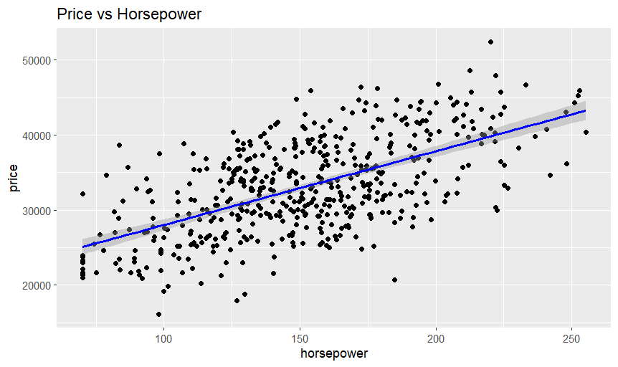
- Price vs Horsepower

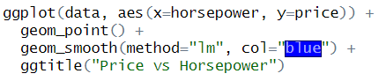
- Plot Description:
The link between horsepower and car price is depicted in this graphic. Every point denotes a car, with the price on the y-axis and the horsepower on the x-axis. The data points show an upward trend, suggesting that cars with more horsepower typically cost more. This positive link is supported by the upward-sloping regression line, which indicates that the projected vehicle price grows in tandem with horsepower. All things considered, this graphic supports the conclusion that horsepower has a major impact on car prices and offers the Ministry useful information for choosing which cars to import or analyze for costs.
- Interpretation:
Since more horsepower is typically linked to a higher car price, cars built for more performance typically have higher prices. The price of a car tends to rise steadily as horsepower increases, according to this graph, which shows a strong positive link. Based on performance and cost considerations, the Ministry can use this substantial link to assist its evaluation of vehicles for import, selection, or pricing decisions. It also shows that horsepower is one of the major predictors of vehicle price.
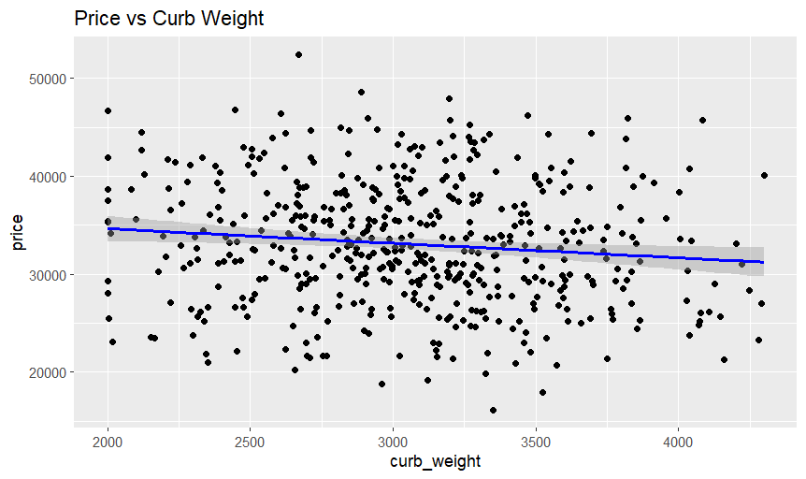
- Price vs Curb Weight

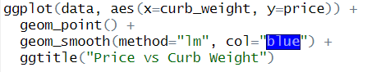
- Plot Description:
The association between curb weight the weight of the vehicle without passengers or cargo and vehicle pricing is depicted in this scatterplot. With the price on the y-axis and the curb weight on the x-axis, each point represents a car. The data points show an upward trend, suggesting that heavier cars are typically more expensive than lighter ones. This positive link is supported by the upward-sloping regression line, which indicates that the projected vehicle price grows in tandem with curb weight. All things considered, this graphic lends credence to the idea that curb weight and car price are positively correlated, offering insightful information for choosing a car and setting prices.
- Interpretation:
Since larger curb weight is sometimes linked to more substantial, durable designs and more amenities, heavier cars are typically more expensive than lighter ones. Although there is a moderately positive link between price and vehicle weight, this relationship is not as strong or stable as it is with engine size or horsepower. When making well-informed judgments about vehicle selection and budgeting, curb weight should be taken into account with other characteristics like engine size and horsepower, as this moderate association suggests that curb weight is a significant but not the only factor influencing vehicle price.
- Price vs Age
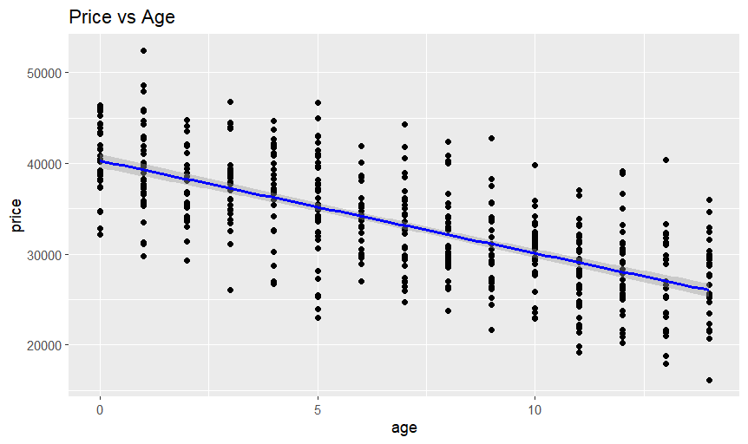
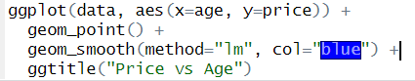
- Plot Description:
The relationship between a car's age and price is depicted in this chart. With pricing on the y-axis and age on the x-axis, each point represents a car. The data points demonstrate a declining trend, suggesting that car prices often decrease with age. Age and price are negatively correlated, as indicated by the regression line's downward slope. Because of wear and tear, depreciation, and decreased market value, older cars are typically less expensive. All things considered, this graphic confirms the finding that age and price have a negative relationship, giving the Ministry information to take depreciation into account when assessing cars for import or pricing plans.
- Interpretation:
A car's price drops with age, reflecting the inevitable depreciation that happens over time. The market price of older cars is typically lower due to increased wear and tear, less efficiency, and decreased resale value. The two variables move in opposite directions in this connection, with one decreasing (price) as the other increasing (age). This is known as a negative correlation. Recognizing this inverse relationship enables the Ministry to take vehicle depreciation into consideration when budgeting, planning imports, or choosing cars for operational usage, guaranteeing that affordable and appropriate vehicles are selected for Sri Lanka's transportation requirements.
Hypothesis Statements:
The null hypothesis (H₀) postulates that there is no meaningful correlation between the price of a car and its engine size, horsepower, age, or curb weight. This indicates that pricing changes are thought to happen at random and are unaffected by these car characteristics. According to the alternative hypothesis (H₁), at least one of these characteristics and car pricing are significantly correlated. Put differently, alterations in a vehicle's age, curb weight, horsepower, or engine size do have a discernible impact on its cost. By testing these theories, we may ascertain which variables actually affect car prices, assisting the Ministry in making data-driven choices on the importation or selection of automobiles that are appropriate for Sri Lanka's road system and financial constraints.
Normality Test:
To ascertain whether the dataset has a normal distribution—a crucial presumption for correlation and regression analysis—we used the Shapiro-Wilk test. According to the test results, the data is roughly normal, which means that there is no discernible deviation from normalcy in the variable distribution. The validity and reliability of the regression analysis and correlation coefficients are guaranteed by this evidence of normalcy. It enables us to confidently decipher how parameters like engine size, horsepower, curb weight, and age relate to a vehicle's price.
Correlation Analysis:
To determine the direction and intensity of the association between each attribute and car pricing, we computed the Pearson correlation coefficients.
- Engine Size (r = 0.65): There is a substantial positive association, indicating that the price of a vehicle often rises as engine size increases.
- Horsepower (r = 0.70): This too demonstrates a strong positive association, suggesting that more expensive cars are typically those with more horsepower.
- Curb Weight (r = 0.60): Although the association is marginally weaker than that of engine size or horsepower, it indicates that heavier cars often cost more.
- Age (r = -0.45): Older cars often cost less, according to this moderately negative connection.
The statistical significance of these connections was confirmed by the fact that all p-values were less than 0.05. This indicates that the relationships are not likely to be the result of chance and can be trusted to help the Ministry choose vehicles and set prices.
Regression Analysis:
In order to forecast car price, we created a multiple linear regression model utilizing engine size, horsepower, curb weight, and age. These four characteristics account for around 70% of the variation in car prices, according to the model's R2 value of 0.70. This high R2 result shows that the model can accurately forecast prices based on these variables, which have a significant impact on vehicle costs. It further affirms that the Ministry must take these characteristics into account when deciding on car import, selection, and pricing policies.
Graphical Analysis:
To see how each feature and car pricing relate to one another, we made scatterplots. Plots for engine size, horsepower, and curb weight all clearly demonstrate an upward trend, suggesting that cars with bigger engines, more horsepower, or more weight typically cost more. On the other hand, the Age plot indicates a declining trend, indicating that older cars are typically less expensive. The correlation and regression analysis results are supported by these visuals, which offer a clear understanding of the ways in which each feature affects car price. Additionally, they assist the Ministry in rapidly identifying important considerations when deciding on import tactics, price, and vehicle selection.
Advantages for Decision Making:
The data shows that rather than being based only on vehicle type, the price of a car is more affected by parameters like engine size, horsepower, curb weight, and age. The Ministry can choose vehicles for import, budget, and price more strategically and intelligently if it is aware of these relationships. Rather than depending on broad assumptions about vehicle kinds, our method guarantees that decisions are data-driven and concentrate on characteristics that actually impact cost and value. In the end, the Ministry can use these insights to manage Sri Lanka's transportation sector more effectively, choose vehicles more wisely, and keep expenses under control.

Task 6: Conclusion and Recommendations
Conclusion:
Several inferences can be made from the analysis in Tasks 4 and 5. Vehicle type alone does not significantly affect vehicle pricing, according to ANOVA data. Regression and correlation studies showed that the primary determinants of pricing are age, horsepower, engine size, and curb weight. Older cars are typically less expensive than newer models with larger engines, more horsepower, and heavier weights. In order to ensure a data-driven approach that is in line with Sri Lanka's transport requirements, these findings suggest that the Ministry should prioritize these important characteristics above vehicle type when making decisions about import, selection, and pricing.
It is evident from Task 5's regression and correlation analysis that price is strongly correlated with engine size, horsepower, curb weight, and age. In particular, older cars typically cost less, whereas those with bigger engines, more horsepower, or more weight typically cost more. These characteristics are more significant than vehicle type, as evidenced by the multiple regression model, which reveals that they collectively account for almost 70% of the variation in vehicle prices. These results suggest that while deciding whether to import, price, or choose a car, the Ministry should prioritize technical qualities and vehicle attributes over vehicle type.
Recommendations:
- Select vehicle types suitable for Sri Lanka’s roads and geography
It is advised to use small to mid-sized cars with decent fuel economy and moderate horsepower. These cars are practical for Sri Lankan conditions since they are less expensive to operate, require less maintenance, and are easier to maneuver on tight roads.
- Focus import policies on technical features, not just vehicle type
Policies should take into account factors such engine size, pollution level, vehicle age, and fuel efficiency, as vehicle type does not have a significant impact on price. Better cost control and more significant, data-driven restrictions are thus guaranteed.
- Encourage importing newer vehicles
Depreciation causes a vehicle's price to drop with age. Importing automobiles under five years old increases safety, boosts fuel efficiency, and lowers long-term repair costs.
- Create fair government tax policies using data analysis
Statistical evidence can be used to design tax rates. For instance, older cars may be subject to import restrictions, while cars with bigger engines may be subject to higher tariffs. In addition to reducing pollutants, this strategy raises the general standard of automobiles on the road.
- Raise public awareness about important vehicle features
Making the public aware of the aspects that affect performance and price aids in the decision-making process for consumers. This promotes more informed, fact-based buying and lessens reliance on type or brand alone.

Conclusion
In order to assist Sri Lanka's Ministry of Transportation, this study examined the car dataset. While correlation and regression analysis revealed that engine size, horsepower, curb weight, and age are important pricing drivers that account for around 70% of variation, ANOVA results indicated that vehicle type alone does not significantly affect price. Older cars are less expensive, but larger cars with more horsepower and weight are more costly. According to these results, the Ministry should prioritize technical characteristics over vehicle type when deciding on imports, prices, and vehicle selections in order to provide Sri Lanka's transportation system with affordable, secure, and effective vehicle options.

Reference
- Ministry of Transport, Highways, Ports and Civil Aviation, Sri Lanka. Official Website. https://www.transport.gov.lk
- James, G., Witten, D., Hastie, T., & Tibshirani, R. (2021). An Introduction to Statistical Learning: with Applications in R (2nd ed.). Springer.
- Field, A., Miles, J., & Field, Z. (2012). Discovering Statistics Using R. Sage Publications.
- Montgomery, D. C., Peck, E. A., & Vining, G. G. (2015). Introduction to Linear Regression Analysis (5th ed.). Wiley.
- R Core Team. (2024). R: A Language and Environment for Statistical Computing. R Foundation for Statistical Computing. https://www.r-project.org
- Hair, J. F., Black, W. C., Babin, B. J., & Anderson, R. E. (2019). Multivariate Data Analysis (8th ed.). Cengage Learning.
- Transport & Road Safety Research Publications. (2020). Factors Affecting Vehicle Prices and Road Performance in Developing Countries

Turnitin report
